Patient Education

Introduction
The purpose of this text is to provide a basic guide to cannabis medicine for cannabis patients, caregivers, and healthcare professionals. This text should not be taken as medical advice. Always consult your physician.
New Mexico Medical Cannabis Law
The Lynn and Erin Compassionate Use Act went into effect in 2007.
What conditions qualify for coverage? Amyotrophic Lateral Sclerosis (ALS), Cancer, Cervical Dystonia, Chronic Pain, Crohn’s Disease, Epilepsy, Glaucoma, Hepatitis C, Human Immunodeficiency Virus (HIV) or Acquired Immune Deficiency Syndrome (AIDS), Hospice Care, Huntington’s Disease, Inclusion Body Myositis, Inflammatory autoimmune- mediated Arthritis, Intractable Nausea/ Vomiting, Multiple Sclerosis, Painful Peripheral Neuropathy, Parkinson’s Disease, Post-Traumatic Stress Disorder (PTSD), Anorexia/ Cachexia, Spinal Cord Damage with Intractable Spasticity, and Ulcerative Colitis.
How much can I possess, for how long? Medical Cannabis cards are only valid for one year and must be renewed annually. As an active cardholder, patients can possess up to eight ounces or 230 grams of medical cannabis every 30 days unless otherwise noted by a physician.
Can I cultivate cannabis as a medical patient? Yes with a Personal Production License.
Can patients still be prosecuted as criminals? Yes.
Right to Use and Possess (covered in Section 5 of the Lynn and Erin Compassionate Use Act)
Section 5. PROHIBITIONS, RESTRICTIONS AND LIMITATIONS ON THE MEDICAL USE OF CANNABIS—CRIMINAL PENALTIES.
A. Participation in a medical use of cannabis program by a qualified patient or primary caregiver does not relieve the qualified patient or primary caregiver from:
(1) criminal prosecution or civil penalties for activities not authorized in the Lynn and Erin Compassionate
Use Act;
(2) liability for damages or criminal prosecution arising out of the operation of a vehicle while under the influence of cannabis; or
(3) criminal prosecution or civil penalty for possession or use of cannabis:
(a) in a school bus or public vehicle;
(b) on school grounds or property;
(c) in the workplace of the qualified patient’s or primary caregiver’s employment; or
(d) at a public park, recreation center, youth center or other public place.
B. A person who makes a fraudulent representation to a law enforcement officer about the person’s participation in a medical use of cannabis program to avoid arrest or prosecution for a cannabis-related offense is guilty of a petty misdemeanor.

What is medical cannabis?
A plant with hundreds of chemical constituents. Including cannabinoids, terpenes, and flavonoids. Cannabis has been used medically and recreationally for most of human history.
Is it safe, can I overdose?
There has never been a recorded death from cannabis overdose. Animal experiments have estimated the lethal dose of cannabis to be 20,000-40,000 times the usual dose. Approximately 40- 80 pounds of cannabis.
Why?
No cannabinoid receptors are in the parts of the brain responsible for breathing. Most drug overdoses are caused by a lack of oxygen to the brain (cerebral hypoxia).
Cannabinoid Receptors? What are those?
All vertebrates (including mammals and humans) have an Endocannabinoid System (ECS).
In all mammals a series of receptors, known as the cannabinoid receptors (CB), are found throughout the body. These receptors act as points of activation on the bodies’ cells, that respond specifically to cannabis. Two types of receptors are found throughout the body:
CB1: Central nervous system, organs, adipose (fat) tissue, connective tissue, nervous system.
CB2: Peripheral nervous system, all immune cells.
A variety of physiological processes including immunity, pain, inflammation, mood, emotion, learning, memory, metabolism, appetite, weight, sleep, neuroprotection and stress response are involved in the ECS.

Cannabis Side Effects
Initial Use:
- Patients first beginning with cannabis may experience mood reactions such as:
  - euphoria, relaxation, time-distortion, enhanced sensory perception, loss of inhibitions, anxiety, paranoia, agitation, delusions or hallucinations.
- Increased heart rate
- Red eyes, dry mouth, headache
- Dizziness or lightheadedness. Novice users are advised to sit up from lying down for 1 to 2 minutes before fully standing up.
- Increased appetite
- Relaxed muscles, loss of coordination
Long -Term Use:
- Chronic coughing or wheezing if medication is smoked.
- May cause changes in short term memory and concentration.
- Weight loss
Overdose:
- No one has ever died of a cannabis overdose.
- Unwanted effects usually resolve as the medication is metabolized. 2-4 hours for inhaled medicating, 6-8 hours for ingested medication.
- Call your doctor or medical professional if side effects persist.
CONSULT YOUR PHYSICIAN IF PREGNANT OR BREASTFEEDING.
CANNABINOIDS PASS THROUGH BREAST MILK.
DO NOT DRIVE OR OPERATE HEAVY MACHINERY WHILE UNDER THE INFLUENCE OF CANNABIS

Cannabis Drug Interactions
The effects of alcohol can be increased when combined with cannabis, increasing risk of dizziness, loss of coordination, nausea, and vomiting.
Use of Cannabis with any prescription medication is never without risk. Inform and discuss your medical cannabis use with your prescribing physician and pharmacist.
Opioids combined with cannabis does not increase the risk of overdose. Use of cannabis can potentially lower the amount of Opioid medication needed for sufficient pain relief.
Sedative medications such as: clonazepam (Klonopin), lorazepam (Ativan), phenobarbital (Donnatal), Zolpidem (Ambien). Extreme tiredness may result in combining sedatives with cannabis.
Disulfiram (Antabuse) manufacturer reports that combined use with cannabis may cause irritability and disturbance of sleep.
Blood thinner medications such as Coumadin (Warfarin) can interact with cannabis. Consult your prescribing physician
Cannabis can lower blood pressure. Blood pressure medications may need to be adjusted while used with medical cannabis.
Cannabis can lower blood glucose levels. Patients on insulin or other diabetes medication should use cannabis with caution and consult their physician.
Mood Stabilizers and other psychiatric medication can affect how cannabis interacts with the body and mind. Changes in psychiatric medication may also change the type of cannabis best suited for the patient.
Antidepressants, such as SSRIs (selective serotonin re-uptake inhibitors) SNRIs (serotonin–norepinephrine reuptake inhibitors), used with cannabis can increase the risk of irritability, nervousness, and serotonin syndrome.

Medical Terms
Analgesic Pain reliever
Anorectic Suppresses appetite
Anti-Arthritic Reduces arthritis symptoms
Anti-Bacterial Kills/ slows the growth of bacteria
Anti-diabetic Reduces blood sugar levels
Anti-depressant Reduces symptoms of depression
Antiemetic Reduces nausea and vomiting
Antiepileptic Reduces-seizures and convulsions.
Anti-fungal Destructive to or checking the growth of fungi
Anti-Inflammatory Reduces inflammation
Anti-ischemic Reduces risk of artery blockage
Anti-insomnia Sleep Aid
Antioxidant Protects against certain type of cell damage
Anti-Proliferative Inhibits cell growth in tumor/ cancer cells
Antipsychotic Reduces symptoms of psychosis
Antispasmodic Suppresses muscle spasms
Anxiolytic Reduces anxiety
Apoptosis Programmed cell death
Bronchodilator Increases lung air flow
Cerebral Of or relating to the brain
Gastrointestinal Stomach related
Immunostimulant Stimulates the immune system
Neuroprotective Preservation of neuronal structure and/or function
Non-Psychotropic Non- intoxicating
Psychotropic Affecting mental activity, behavior, or perception, as a mood-altering drug
Physiology Functions of living organisms and their parts
Cannabis Consumption Methods
Oral
Juicing- Non-psychotropic (not intoxicating)
Useful for autoimmune disorders.
Whole plant can be juiced for medical benefits.
Edibles- Food product containing cannabis.
Full effects may take up to 2 hours to onset.
New users are advised to dose no more than 5 miligrams of THC.
Ultra Health in a proud member of the Oregon Responsible Edible Council. Visit http://orediblescouncil.com/ for more information on Oregon’s responsible edible campaign (OREC).

Tinctures- Sublingual (under the tongue)
Glycerin tinctures are sweet and can be cooked or cold pressed. Alcohol tinctures may burn under the tongue but can also be cooked or diluted for easier consumption. Adding tinctures to liquids such as coffee or juice can also be effective.
Body
Suppositories- Can be used vaginally and rectally.
Rectal suppositories should be inserted 1-2 inches in order for the medication to bypass the veins leading to the liver.
Topical- Applied to the surface of the skin.
Transdermal patches, lotions and other bath products.
Inhaled
Vaporization- Inhalation method that eliminates irritants and carcinogens produced by combustion (smoking) Vaporization of cannabinoids occurs at 356-392°F. Terpenes vaporize at 259 °F.
Smoking- Fastest and most cost effective way to medicate. Smoke is produced by combustion, which also creates carcinogens. Smoking any substance has health risks. Water pipes / bongs are less irritating than a joint of blunt. Avoiding tobacco products commonly with cannabis is advised.

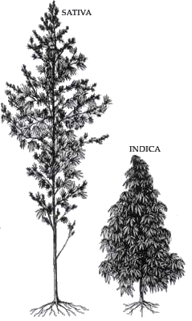

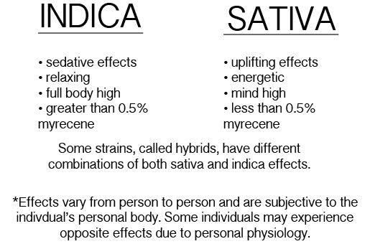

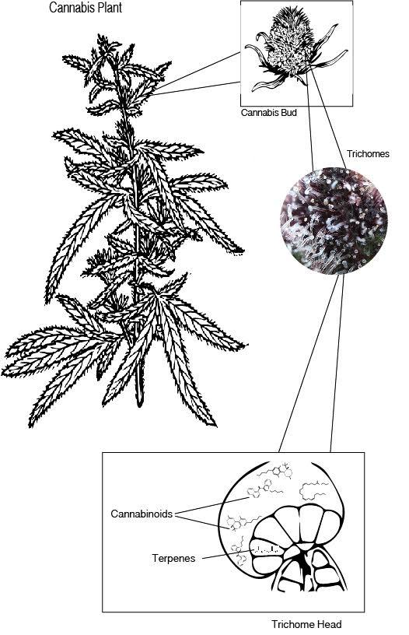
Flower: The “bud” of the cannabis plant.

Trichrome- Small, mushroom-like resin glands on the surface of the plant. Contains the cannabinoids and terpenes.

Cannabis Components
Cannabinoid- the main chemical component on Cannabis. Molecules that act on cannabinoid receptors in the body.
Terpenes- are responsible for the aroma of Cannabis. Over 100 different terpenes have been identified in the Cannabis plant. The terpene profile determines if a strain is more Indica or Sativa.
Flavonoids- are a nutrient group with over 6,000 types. About 20 of these compounds, have been identified in the Cannabis plant. Apigenin, quercetin, cannflavin A and B are flavonoids found only in cannabis.
Medication Equipment Terminology
Grinder- Many patients prefer to grind their medicine for a smoother smoke. Cannabis specific grinders are available for medical patients.
Joint/ Pre-Roll - Ground cannabis rolled into hemp paper.
Glass- Piece, utensil, or object that is used to smoke cannabis.
Carb- Small hole in the glass. Mixes air with smoke. Thumb is usually placed over the carb while inhaling.
Pipe - Glass, usually small. Used to smoke flower.
Water pipe/ Bong- Glass requiring water. Used to smoke flower.
Bowl- Attaches to bong or water pipes. Holds the flower.
Rig- Glass specifically designed for concentrates.
Nail- Glass, titanium, and quartz are used instead of a bowl piece for flower. The nail is heated before “dabbing” concentrates. Some nails also have a dome design.
Dabber- Piece of metal specifically designed to handle concentrates. Used to apply medicine to heated nail.
Torch- Most use butane, used to heat the nail.
Storage- It is highly recommended storing your medicine in an airtight dark container, in a moderate dry environment.
Cannabis Concentrates
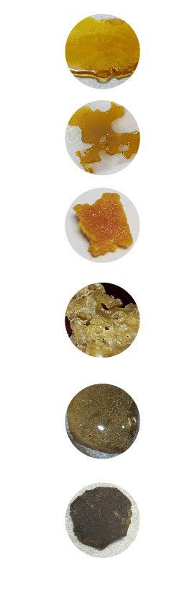
Referred to as: wax, oil, dabs. Condensed cannabinoid products made with or without a solvent.
Solvent- a substance that can dissolve another substance.
BHO- “Butane Hash Oil” is created by blasting cannabis plant matter with butane. Next the product is purified or “purged” to remove as much leftover solvent (the butane) as possible. Several methods can be used to produce a variety of textures/ types of concentrates.
Shatter- Light gold to dark gold/ brown. Texture ranges from taffy-like to hard candy.
Live Resin- Fresh plant matter is frozen and not cured. Then the plant material is processed with butane. Similar to Shatter
Budder- Light to medium blonde color. Butter-like texture.
Sugar Wax- Light gold to dark gold/ brown. Granulated wax-like texture.
Crumble/ Honeycomb- Light to medium blonde color. Clay texture with added air. Some have air bubbles.
Solvent less- An extract created with heat, pressure, and water.
CO2 Oil - Tends to be soft or runny, and usually amber colored. Produced with carbon dioxide instead of butane.
Rosin - A solvent less extract that uses heat and pressure to concentrate essential cannabis compounds.
Kief- powder like substance from dried trichrome glands from the flower.
Hash- Light to dark brown. Can be made with silk screens (bubble hash) or dry ice.

Cannabinoids
Heated:
- THC
  - Anti-bacterial
  - Inhibits cell growth in tumors/cancer cells
  - Suppresses muscle spasms
  - Relieves pain
  - Reduces nausea and vomiting
  - Appetite stimulant
  - Bone stimulant
  - Neuroprotective
- CBD
  - Anti-inflammatory
  - Anti-bacterial
  - Inhibits cell growth in tumors/cancer cells
  - Reduces nausea
  - Analgesic
  - Lowers blood sugar levels
  - Reduces risk of artery blockage
  - Treats psoriasis
  - Antipsychotic
  - Suppresses muscle spasms
  - Relieves anxiety
  - Promotes bone growth
  - Modulates function in immune system
  - Reduces small intestine retractions
  - Neuroprotective
- CBC
  - Anti-inflammatory
  - Inhibits cell growth in tumors/cancer cells
  - Analgesic
  - Promotes bone growth
  - Assists in contraction of blood cells
- CBG
  - Anti-inflammatory
  - Anti-oxidant
  - Anti-bacterial
  - Inhibits cell growth in tumors/cancer cells
  - Promotes bone growth
  - Antidepressant
- THCV
  - Anti-inflammatory
  - Anti-convulsive
  - Suppresses appetite
  - Bone stimulant
  - Neuroprotective

Raw:
- THCa
  - Anti-inflammatory
  - Inhibits cell growth in tumors/cancer cells
  - Suppresses muscle spasms
- CBDa
  - Anti-inflammatory
  - Anti-bacterial
  - Inhibits cell growth in tumors/cancer cells
  - Reduces nausea and vomiting
- CBCa
  - Anti-inflammatory
  - Anti-bacterial
  - Anti-fungal
- CBGa
  - Anti-inflammatory
  - Relives pain
Aged:
- CBN
  - Relieves pain
  - Anti-bacterial
  - Anti-insomnia
  - Suppresses muscle spasms
  - Promotes cancer cell death by apoptosis
- CBNa
  - Anti-inflammatory
- CBLa
  - Anti-inflammatory

Terpenes
- Pinene
  - Relieves pain
  - Slows bacterial growth
  - Anti-inflammatory
  - Inhibits cancer cell growth
  - Antioxidant
  - Bronchodilator
  - Enhances focus
  - Also found in pine needles and rosemary.
- Limolene
  - Antidepressant
  - Antifungal
  - Anti-inflammatory
  - Inhibits cell growth
  - Relieves anxiety
  - Reduces acid reflux
  - Stimulates the immune system
  - Also found in lemons, limes, oranges and other citrus.
- Humulene
  - Relieves pain
  - Slows bacterial growth
  - Anti-inflammatory
  - Inhibits cancer cell growth
  - Appetite suppressant
  - Promotes weight loss
  - Also found in hops and coriander.
- Terpinolene
  - Antibacterial
  - Antifungal
  - Aids with sleep
  - Inhibits cancer cell growth
  - Antioxidant
  - Commonly used in soaps, perfumes and as insect repellant.
- Linalool
  - Relieves pain
  - Antidepressant
  - Reduces seizures and convulsions
  - Anti-inflammatory
  - Antipsychotic
  - Relieves anxiety
  - Promotes sleep
  - Also found in lavender.
- Myrecene
  - Relieves pain
  - Antibacterial
  - Anti-diabetic
  - Anti-inflammatory
  - Aids with sleep
  - Inhibits cell mutation, including cancer cells
  - Antipsychotic
  - Suppresses muscle spasms
  - Also found in mangoes, basil and lemongrass.
- Caryophyllene
  - Relieves pain
  - Antibacterial
  - Antidepressant
  - Anti-inflammatory
  - Inhibits cancer cell growth
  - Antioxidant
  - Helps relieve anxiety
  - Slows damage to the nervous system and brain
  - Also found in hops and coriander.

